Solutions to Chapter 5 Exercises
SOLVED EXERCISES
S1. (a) R’s best-response rule is given by y = 10√x – x. L spends $16 million, so x = 16. Then R’s best response is y = 10√16 – 16 = 10(4) – 16 = 40 – 16 = 24, or $24 million.
(b) R’s best response is y = 10√x – x, and L’s best response is x = 10√y – y. Solve these simultaneously:
x = 10(10√x – x)^{1/2} – 10√x + x
⇒ √x = (10√x – x)^{1/2}
- x = 10√x – x
- 2x = 10√x
- √x = 5
- x = 25
y = 10√25 – 25 = 25

S2. (a) Xavier’s costs have not changed, nor have the demand functions, so Xavier’s best-response rule is still the same as in Figure 5.1: P_{x} = 15 + 0.25P_{y}. Yvonne’s new profit function is B_{y} = (P_{y} – 2)Q_{y} = (P_{y} – 2)(44 – 2P_{y} + P_{x}) = – 2(44 + P_{x}) + (4 + 44 + P_{x})P_{y} – 2(P_{y})². Rearranging or differentiating with respect to P_{y} leads to Yvonne’s new best-response rule: P_{y} = 12 + 0.25P_{x}. Solving the two response rules simultaneously yields P_{x} = 19.2 and P_{y} = 16.8.
(b) See the graph below. Yvonne’s best-response curve has shifted down; it has the same slope but a new, lower intercept (12 rather than 15). Yvonne is able to charge lower prices due to lower costs. The new intersection point occurs at (19.2, 16.8) as calculated above.
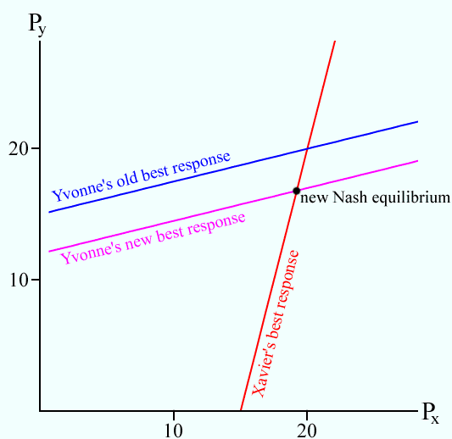

S3. (a) La Boulangerie’s profit is:
Y₁ = P₁Q₁ – Q₁ = P₁ (14 – P₁ – 0.5P₂) – (14 – P₁ – 0.5P₂) = – P₁² + 15P₁ – 0.5P₁P₂ + 0.5P₂ – 14.
To find the optimal P₁ without using calculus, we refer to the result in the Appendix to Chapter 5, remembering that P₂ is a constant in this situation. Using the notation of the Appendix, we have A = 0.5P₂ – 14, B = 15 – 0.5P₂, and C = 1, so the solution is:
P₁ = B/(2C) = 15 – 0.5P₂/(2), or P₁ = 7.5 – 0.25P₂.
This is La Boulangerie’s best-response function. You get the same answer by setting = –2P₁ + 15 – 0.5P₂ = 0 and solving for P₁.
Similarly, La Fromagerie’s profit is:
Y₂ = P₂Q₂ – 2Q₂ = P₂(19 – 0.5P₁ – P₂) – 2(19 – 0.5P₁ – P₂) = – P₂² + 21P₂ – 0.5P₁P₂ + P₁ – 38.
Again, using the notation in the Appendix, A = P₁ – 38, B = 21 – 0.5P₁, and C = 1, which yields:
P₂ = B/(2C) = 21 – 0.5P₁/(2), or P₂ = 10.5 – 0.25P₁.
This is La Fromagerie’s best-response function. You get the same answer by setting 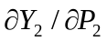= – 2P₂ + 21 – 0.5P₁ = 0 and solving for P₁.
To find the solution for the equilibrium prices analytically, substitute La Fromagerie’s best-response function for P₂ into La Boulangerie’s best-response function. This yields P₁ = 7.5 – 0.25(10.5 – 0.25P₁), or P₁ = 5.2. Given this value for P1, you can find P2 = 10.5 – 0.25(5.2) = 9.2. The best-response curves are shown in the diagram below.
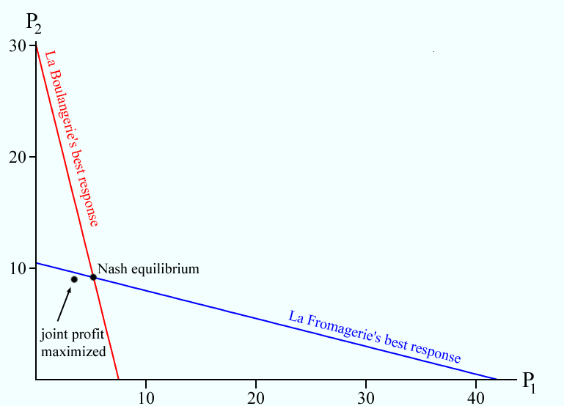

(b) Colluding to set prices to maximize the sum of profits means that the firms maximize the joint-profit function:
Y = Y₁ + Y₂ = 16P₁ + 21.5P₂ – P₁² – P₂² – P₁P₂ – 52.
To answer without calculus, use the result in the Appendix. Using that notation to solve for P₁, A = 21.5P₂ – P₂² – 52, B = 16 – P₂, and C = 1, so the solution is:
P₁ = B/(2C) = 16 – P₂/(2), or P₁ = 8 – 0.5P₂.
Similarly, solving for P₂, A = 16P₁ – P₁² – 52, B = 21.5 – P₁, and C = 1, so the solution is:
P₂ = B/(2C) = 21.5 – P₁/(2), or P₂ = 10.75 – 0.5P₂.
Solving these two equations simultaneously yields the solution P₁ = 3.5 and P₂ = 9.
You can get the same answer by partially differentiating the joint-profit function with respect to each price. Profits must be maximized with respect to both P₁ and P₂, so we need = 16 – 2P₁ – P₂ = 0 and = 21.5 – P₁ – 2P₂ = 0.
(c) When firms choose their prices to maximize joint profit, they act as a single firm and ignore any individual incentives that they might have to deviate from the joint profit goal. However, given their partner’s collusive price, each company can reap more profit individually by charging more. For instance, plugging the joint-profit-maximizing value of La Boulangerie’s price into La Fromagerie’s individual best-response rule will not yield La Fromagerie’s joint profit-maximizing price:
P₂ = 10.5 – 0.25(3.5) = 9.625 ≠ 9.
Likewise, plugging the joint-profit-maximizing value of La Boulangerie’s price into La Fromagerie’s individual best-response rule gives:
P₁ = 7.5 – 0.25(9) = 4.75 ≠ 3.5.
Thus, the two joint profit-maximizing prices are not best responses to each other; that is, they do not form a Nash equilibrium.
(d) When firms produce substitutes, a drop in price at one store hurts the sales of the other. Thus, as your rival drops her price, you also want to drop yours to attempt to maintain sales (and profits). In the bistro example in the text and in Exercise 1 above, this result led to best-response curves that were positively sloped and Nash equilibrium prices that were lower than the joint-profit-maximizing prices. Here, the firms produce complements, so a drop in price at one store leads to an increase in sales at the other. In this case, as one store drops its price, the other can safely increase its price somewhat and still maintain sales (and profits). Thus, the best-response curves are negatively sloped, and the Nash equilibrium prices are higher than the joint-profit-maximizing prices.

S4. To rationalize the nine possible outcomes, you need a separate argument for each one. We offer just one example, leaving you to construct the rest. Note that you need not consider the strategy combination (A, A) since that is a Nash equilibrium and therefore rationalizable. Consider (A, C) leading to the payoffs (0, 2). C is a possible best response for Column if he thinks that Row is playing A. Why does Column believe this? Because he believes that Row believes that Column is playing B. Column justifies this belief by thinking that Row believes that Column believes that Row is playing C. The beliefs in this chain are all perfectly rational because each strategy of either player is a best response (or among the best responses) to some strategy of the rival player.

S5. No matter what beliefs Column might hold about what Row is playing, South is never Column’s best response. Therefore South is not a rationalizable strategy for Column. Since Row recognizes this, and since Earth is Row’s best response only against Column’s South, Row does not play Earth. Since North is Column’s best response only against Earth, Column will not play North. Since Column will never play North or South, Wind is never a best response for Row. The remaining strategies—Water and Fire for Row and East and West for Column—are used in the two pure-strategy Nash equilibria, so they are certainly rationalizable.

S6. Using the third-round range of X, we have that Y = 12 – X/2 must be at most 12 – 9/2 = 12 – 4.5 = 7.5 (nothing new here) and at least 12 – 12.75/2 = 12 – 6.375 = 5.625 (a narrowing of the range: after the third round, the lower bound was 4.5). Similarly, using the third-round range of Y, we find that X = 15 – Y/2 must be at most 15 – 4.5/2 = 15 – 2.25 = 12.75 (nothing new) and at least 15 – 7.5/2 = 15 – 3.75 = 11.25 (a narrowing of the range: in the third round, the lower bound was 9). We see that in even rounds the lower bounds get tighter, and in odd rounds the upper bounds get tighter.

S7. (a) Cart 0 serves x customers and Cart 1 serves (1 – x), where x is defined by the equation p₀ + 0.5x² = p₁ + 0.5 (1 – x)². Expanding this equation yields p₀ + 0.5x² = p₁ + 0.5 – x +0.5x², and solving for x yields x = p₁ – p₀ + 0.5. Thus Cart 0 serves p₁ – p₀ + 0.5 customers, and Cart 1 serves 1 – x, or p₀ – p₁ + 0.5, customers.
(b) Profits for Cart 0 are (p₁ – p₀ + 0.5)(p₀ – 0.25). Profits for Cart 1 are symmetric:
(p₀ – p₁ + 0.5)( p₁ – 0.25). Expanding the expression for Cart 0 profits yields (p₁ – p₀ + 0.75)p₀ – (0.25 p₁ + 0.125). Solving for the profit-maximizing value of p₀ by completing the square or differentiating with respect to p₀ yields p₀ = 0.5p₁ + 0.375. Cart 1’s best-response rule is symmetric: p₁ = 0.5p₀ + 0.375.
(c) The graph is shown below. The Nash equilibrium prices are the values of p₀ and p₁ that solve simultaneously the two best-response rules found in part (b). Substituting Cart 1’s best-response rule into that for Cart 0, we find: p₀ = 0.5(0.5p₀ + 0.375) + 0.375 = p₀ + 0.5625. Solving for p₀ yields p₀ = 0.75 (75¢); Cart 1’s price is p₁ = 0.75 (75¢) also.

S8. (a) South Korea’s profit is
Y_{Korea} = q_{Korea}*P – c_{Korea}*q_{Korea} = q_{Korea}(180 – Q) – 30q_{Korea}
= q_{Korea}(180 – q_{Korea} – q_{Japan}) – 30q_{Korea} = –q_{Korea}² + (180 – 30)q_{Korea} – q_{Korea}*q_{Japan}. Using the notation in the Appendix yields A = 0, B = 150 –q_{Japan}, and C = 1, so South Korea’s best response is:
q_{Korea} = B/(2C) = 150 – q_{Japan}/(2), or q_{Korea} = 75 – 0.5q_{Japan}.
This is South Korea’s best-response function. You get the same answer by setting 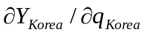 = –2q_{Korea} + 150 – q_{Japan} = 0 and solving for q_{Korea}.
Since Japan has the same price and cost per ship as South Korea, Japan’s profit is
Y_{Japan} = –q_{Japan}² + (180 – 30)q_{Japan} – q_{Korea}*q_{Japan}.
Similarly, Japan’s best-response function is:
q_{Japan} = 75 – 0.5q_{Korea}.
(b) To find the solution for the equilibrium prices, substitute Japan’s best-response function for q_{Japan} into South Korea’s best-response function. This yields:
q_{Korea} = 75 – 0.5q_{Japan} = 75 – 0.5(75 – 0.5q_{Korea}) = 37.5 + 0.25q_{Korea}
⇒ q_{Korea} = 50
Therefore:
q_{Japan} = 75 – 0.5(50) = 50.
The price of a VLCC is given by the expression P = 180 – Q where Q = q_{Korea} + q_{Japan} = 50 + 50 = 100. Therefore P = 180 – 100 = 80, or $80 million.
South Korea’s profit is Y_{Korea} = –q_{Korea}² + (180 – c_{Korea})q_{Korea} – q_{Korea}*q_{Japan} = –(50)² + (180 – 30)(50) – (50)(50) = –2500 + 7500 – 2500 = 2500.
Likewise, Japan’s profit is Y_{Japan} = –q_{Japan}² + (180 – c_{Japan})q_{Japan} – q_{Korea}*q_{Japan} = 2500. Therefore both countries make $2.5 billion in profits.
(c) South Korea’s new best-response function is:
q_{Korea} = 90 – 0.5c_{Korea} – 0.5q_{Japan} = 90 – 0.5(20) – 0.5q_{Japan} = 80 – 0.5q_{Japan}.
Japan’s new best-response function is:
q_{Japan} = 90 – 0.5c_{Japan} – 0.5q_{Korea} = 90 – 0.5(40) – 0.5q_{Korea} = 70 – 0.5q_{Korea}.
To find the solution for the new equilibrium prices, substitute Japan’s new best-response function for q_{Japan} into South Korea’s best-response function. This yields:
q_{Korea} = 80 – 0.5q_{Japan} = 80 – 0.5(70 – 0.5q_{Korea}), or q_{Korea} = 60.
Given this value for q_{Korea},
q_{Japan} = 70 – 0.5q_{Korea} = 70 – 0.5(50), or q_{Japan} = 45.
South Korea’s market share is 60 / (60 + 45) ≈ 57%, and Japan’s market share is approximately 43%.
South Korea’s profit is:
Y_{Korea} = –q_{Korea}² + (180 – c_{Korea})q_{Korea} – q_{Korea}q_{Japan} = – (60)² + (180 – 20)(60) – (60)(45)
= –3600 + 9600 – 2700 = 3300, or $3.3 billion.
Japan’s profit is:
Y_{Japan} = –q_{Japan}² + (180 – c_{Japan})q_{Japan} – q_{Korea}q_{Japan} = – (45)² + (180 – 40)(45) – (60)(45)
= –2025 + 6300 – 2700 = 1575, or $1.575 billion.

S9. (a) South Korea’s profit is Y_{Korea} = q_{Korea}P – c_{Korea}q_{Korea} = q_{Korea}(180 – Q) – 30q_{Korea} = q_{Korea}(180 – q_{Korea} – q_{Japan} – q_{China}) – 30q_{Korea} = –q_{Korea}² + (180 – 30)q_{Korea} – q_{Korea}q_{Japan} – q_{Korea}q_{China}.
Using the notation in the Appendix, A = 0, B = 150 – q_{Japan} – q_{China}, and C = 1, so the solution is q_{Korea} = B/(2C) = (150 – q_{Japan} – q_{China})/2, or q_{Korea} = 75 – 0.5q_{Japan} – 0.5q_{China}. This is South Korea’s best-response function. You get the same answer by setting = –2q_{Korea} + 150 – q_{Japan} – q_{China} = 0 and solving for q_{Korea}.
Since Japan and China face the same price (P = 180 – Q) and cost (c_{Korea} = c_{Japan} = c_{China}) as South Korea, the best response functions for Japan and China are:
q_{Japan} = 75 – 0.5q_{Korea} – 0.5q_{China}
q_{China} = 75 – 0.5q_{Korea} – 0.5q_{Japan}
(b) To find the solution for the equilibrium prices, first substitute China’s best-response function into Japan’s best-response function:
q_{Japan} = 75 – 0.5q_{Korea} – 0.5(75 – 0.5q_{Korea} – 0.5q_{Japan})
⇒ q_{Japan} = 50 – q_{Korea}/3.
Next, substitute Japan’s best-response function into China’s best-response function:
q_{China} = 75 – 0.5q_{Korea} – 0.5(75 – 0.5q_{Korea} – 0.5q_{China})
⇒ q_{China} = 50 – q_{Korea}/3.

Then substitute these expressions for q_{Japan} and q_{China} into South Korea’s best-response function:
q_{Korea} = 75 – 0.5q_{Japan} – 0.5q_{China} = 75 – 0.5(50 – q_{Korea}/3) – 0.5(50 – q_{Korea}/3) = 25 + q_{Korea}/3
- q_{Korea} = 37.5.
Japan and China have symmetric best response functions, so q_{Japan} = 37.5 and q_{China} = 37.5.
Each country produces 37.5, so each has a market share of 33.3%.
Since each country has the same market share, price, and cost, they will all earn the same profit. South Korea’s profit is:
Y_{Korea} = –q_{Korea}² + (180 – 30)q_{Korea} – q_{Korea}*q_{Japan} – q_{Korea}*q_{China}
= –(37.5)² + (150)(37.5) – (37.5)(37.5) – (37.5)(37.5) = 1406.25, or $1,406.25 million.
(c) In the duopoly situation, each country produced 50 VLCCs per year at a price of $80 million each, for a profit of $2.5 billion per country. In the triopoly, each country produced 37.5 VLCCs per year at a price of $67.5 million each. The third producer increases the total output (supply), lowering the price per VLCC and therefore the profits made per country. There is a greater number of VLCCs available for purchase, but this lowers the price and therefore also the collective profits (roughly $4.2 billion versus $5 billion), which are now split among three countries instead of between two.

S10. (a) Since the joint profits of the partnership are split equally, Monica and Nancy each get a payoff of 0.5(4m + 4n + mn) = 2m + 2n + 0.5mn, minus her own effort cost. Therefore Monica’s payoff is 2m + 2n + 0.5mn – m² and Nancy’s payoff is 2m + 2n + 0.5mn – n². If m = n = 1, each partner receives a payoff of 2(1) + 2(1) + 0.5(1)(1) – 1 = 3.5, or $35,000.
(b) We find Nancy’s best-response function by maximizing the expression Y_{n} = 2m + 2n + 0.5mn – n². Using the notation in the Appendix, A = 2m, B = 2 + 0.5m, and C = 1, so Nancy’s best-response function is:
n = B/(2C) = 2 + 0.5m/(2) = 1 + 0.25m.
You get the same answer by setting = -2n + 2 + 0.5m = 0 and solving for n.
When Monica puts in effort of m = 1, Nancy’s best response is:
n = 1 + 0.25m = 1 + 0.25(1) = 1.25.
(c) We know from part (b) that Nancy’s best-response function is n = 1 + 0.25m. The game is symmetric; Monica’s best-response function is m = 1 + 0.25n. To find the solution for the equilibrium effort levels, substitute Nancy’s best-response function into Monica’s best-response function:
m = 1 + 0.25(1 + 0.25m) ⇒ m = 4/3.
Given this value of m, Nancy’s effort will be:
n = 1 + 0.25(4/3) = 4/3.
The Nash equilibrium to this game has both Monica and Nancy putting in an effort of 4/3.

S11. Because Xavier cannot rationally believe that Yvonne will charge a negative price, and because his best-response function is P_{x} = 15 + 0.25P_{y}, his own price P_{x} can never be below 15. A similar calculation done by Yvonne ensures that her price P_{y} cannot be less than 15 either. In the second round of this thinking, each sees through the other’s first-round thinking, and therefore does not set a price less than 15 + 0.25(15) = 18.75.
However, this narrows the range of prices only from below the Nash equilibrium. To narrow from above, we need a starting point, namely an upper limit to the prices, such that no rational player would ever contemplate charging anything higher. If there were a price so high that you would sell nothing if you charged that, no matter the other’s price, that would do. However, for the linear functions stipulated here, that is not the case. Consider Xavier. Might he charge P_{x} = 1,000? That would be his best response if he believed that Yvonne would charge P_{y} = (P_{x} – 15)/0.25 = 4 × 985 = 3,940, in which case he would sell Q_{x} = 44 – 2 × 1,000 + 3,940 = 1,984. And he might believe that Yvonne would charge P_{y} = 3,940 because he thinks she believes that he would charge P_{x} = (3,940 – 15)/0.25 = 15,700, in which case she would expect to sell Q_{y} = 44 – 2 × 3,940 + 15,700 = 7,864. And so on. Of course these are absurd prices for meals, but that is because the linear functions we stipulated are unlikely to be valid over such a large range. If it is not rational for anyone to charge a price higher than, say, 500, then because they know this, in the second round of thinking it is not rational for either to charge a price higher than 15 + 0.25 × 500 = 140. In the third round of thinking this upper limit drops to 15 + 0.25 × 140 = 50, and so on, eventually converging to the Nash equilibrium level of 20.

S12. (a) The average of all numbers must be between 0 and 100. Thus the target number must be between (2/3)*0 and (2/3)*100, or 0 and 66.67. Therefore choosing any number above 66.67 is a strictly dominated strategy.
(b) If all of Elsa’s classmates choose 40, then X = [49(40) + n]/50 = (1960 + n)/50, where n is the number Elsa selects. To win, Elsa’s number must be closer to two-thirds X than 40. Because of this, we know that Elsa will select a number less than 40. Then we solve for 40 – (2/3)X > (2/3)X – n, or 40 – (2/3)[(1960 + n)/50] > (2/3)[(1960 + n)/50] – n, which simplifies to n > 12.60. Therefore the set of best responses in this situation is 12.60 ≤ n < 40.
(c) Similarly, if Elsa knew that all of her classmates would submit the number 10, then X = [49(10) + n]/50 = (490 + n)/50. For Elsa to win, her number must be closer to two-thirds X than 10. Again, we know that Elsa will select a number less than 10. Then we solve for 10 – (2/3)X > (2/3)X – n, or 10 – (2/3)[(490 + n)/50] > (2/3)[(490 + n)/50] – n, which simplifies to n > 3.15. Therefore the set of best responses in this situation is 3.15 ≤ n < 10.
(d) At a symmetric Nash equilibrium, all students will be choosing the same number. From parts (b) and (c) above, we see that there is an incentive to deviate from any number played by everyone else in the class if that number is positive. Zero, however, works as a symmetric Nash equilibrium strategy because it is its own best response: 0 = (2/3)*0.
(e) To find rationalizable strategies to this game, use iterated elimination of never-best responses. We know from part (a) that any number greater than 66.67 is never a best response. On the basis of this fact, we determine that (2/3)*66.67 = 44.45 is also never a best response. You continue this iterated elimination until you are left with the only rationalizable strategy in the game, which is choosing zero.

